**LAB # 06**

**RIP (Routing Information Protocol)**

**OBJECTIVE:**

To Observe the behaviour of the RIP

1. The ***Routing Information Protocol***, or **RIP** for short, is a dynamic local and wide-area network distance vector, interior gateway protocol
2. Routers have only information pertaining to directly attached interfaces, neighboring routes must be discovered.
3. Routers use distance vector algorithms (such as RIP) and routing tables to discover, analyze, and record distances between possible destinations.

**RIP Version 1**

1. RIPv1 is known as a classful routing protocol
2. RIPv1 transports routing table updates in IP packets
3. RIPv1 also supports no method to authenticate router updates, which leaves the network vulnerable to malicious attacks.

**RIP Configuration**

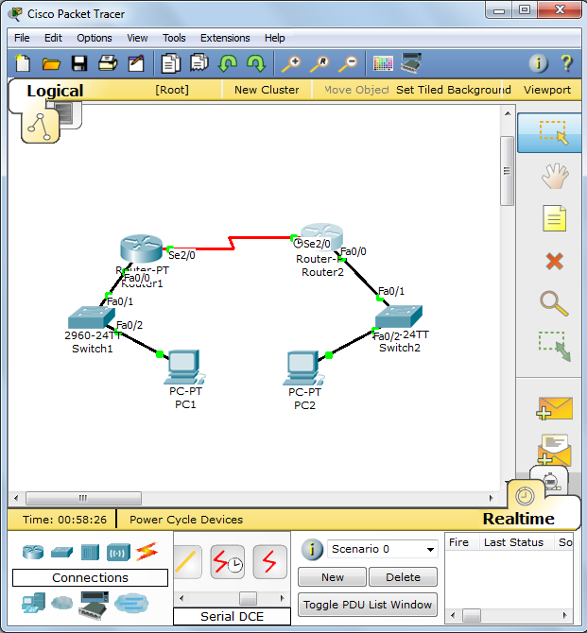

* **Router1 CONFIGURATION**

Router1(config)# **interface serial 2/0**

Router1(config-if)# **no shutdown**

Router1(config-if)# **ip address 10.0.0.1 255.0.0.0**

Router1(config-if)#**clock rate 64000**

Router1(config)# **interface fastEthernet 0/0**

Router1(config-if)# **ip address 11.0.0.1 255.0.0.0**

Router1(config-if)# **no shutdown**

* **Configuring RIP**

Router1(config)# **router rip**

**Add only networks that are configured on R1 router**

Router1(config-router)# **network 10.0.0.0**

Router1(config-router)# **network 11.0.0.0**

* **Router2 CONFIGURATION**

Router2(config)# **interface serial 2/0**

Router2(config-if)# **no shutdown**

Router2(config-if)# **ip address 10.0.0.2 255.0.0.0**

Router2(config-if)# **exit**

Router2(config)# **interface fastEthernet 0/0**

Router2(config-if)# **ip address 12.0.0.1 255.0.0.0**

Router2(config-if)# **no shutdown**

* **Configuring RIP**

Router2(config)# **router rip**

Router2(config-router)# **network 10.0.0.0**

Router2(config-router)# **network 12.0.0.0**

**RIP Verification**

Router1# **show ip route**

Codes: C - connected, S - static, R - RIP, M - mobile, B - BGP

D - EIGRP, EX - EIGRP external, O - OSPF, IA - OSPF inter area

N1 - OSPF NSSA external type 1, N2 - OSPF NSSA external type 2

E1 - OSPF external type 1, E2 - OSPF external type 2

i - IS-IS, su - IS-IS summary, L1 - IS-IS level-1, L2 - IS-IS level-2

ia - IS-IS inter area, * - candidate default, U - per-user static route

o - ODR, P - periodic downloaded static route

Gateway of last resort is not set

C 10.0.0.0/8 is directly connected, Serial2/0

C 11.0.0.0/8 is directly connected, FastEthernet0/0

R 12.0.0.0/8 [120/1] via 10.0.0.2, 00:00:04, Serial2/0

* **‘R’ shows the routes learned by the RIP dynamically, 120 in brackets is that AD and 1 is the cost of reaching that network**